GASSD Quarterly
Newsletter

“Committed To Neighborhood Excellence”

Volume 1, Issue 1
What’s New on Grand?

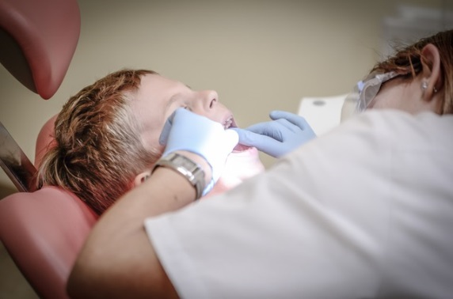
Hello Spring! Warm weather is right around the corner! It’s time for sunshine, long walks on the beach and of course, “GREAT FOOD!” Stop by Cositas Ricas for a refreshing smoothie or grab a slice of goodness from Ziggy's Pizza. Cositas Ricas offers yummy treats such as smoothies, Italian ice and milk shakes. They also sell quesadillas, tacos and Mexican sandwiches. You are sure to find a fresh treat here. The store is open until 10 pm throughout the summer. If you’re not in the mood for desserts and are feeling hungry, Ziggy’s pizza will surely satisfy the pizza lover’s appetite. The most popular items include wings, mozzarella cheese pizza and meat lover’s pizza. As the largest area of Latino-owned businesses in New Haven, Grand Avenue is rich in food and culture. Let your taste buds go wild as you power your day on Grand!

Calling All Smiles
A healthy mouth is very important. Brushing and flossing daily ensures that you are making the appropriate steps to keep your mouth refreshed and clean. According to the American Dental Association, a comprehensive dental routine consists of keeping up with your regularly scheduled dental exams, keeping up with toothbrush replacement every 3-4 months and brushing and flossing twice a day. Fair Haven Community Health Center has a brand new dental office that offers cleanings, extractions, fillings, exams, x-rays and sealants for the prevention of cavities. Take advantage today and happy smiling. The new office is located at 50 Grand Avenue.

You’re Cordially Invited
Neighborworks New Horizon is hosting its, “Homes Matter to Everyone,” 24th Annual Meeting on Thursday, May 11th. Each year, the annual meeting brings together individuals who have a passion for Connecticut residents to receive affordable housing. This year’s gala will be held from 5:30-10:30 pm at the Woodwinds in Branford, CT. Tickets are on sale through their website (www.nwnh.com). Stop by their office at 235 Grand Avenue if you have any questions regarding rental, budget coaching and first time home buyer education. Don’t miss an opportunity to make an impact.

Friend’s Center for Children Makes a Difference
Is your child 3 months to 5 years old? Is your child in need of full-time, year-round care? If you’ve answered yes to both of these questions, the Friend’s Center for Children is a step in the right direction. FCC is a full-time early childhood educational center which utilizes a curriculum based on "Values," and a, "Child Centered Philosophy.” With a low ratio of 3 to 1, every child has the opportunity to succeed. FCC’s hands on approach creates an atmosphere of nurturing, safety and support for everyone. For more information, visit 227 Grand Avenue or call (203) 468-1966.
Fair Haven Community Health Center
Nurturing Families Center
Are you a first time parent? Stop by the office of Fair Haven Community Health Center. With a focus on parental and familial development, the Nurturing Families Center offers resources, emotional support, home visiting services and much more. For more information, visit the Center at 374 Grand Avenue or call 203-777-7411 ext 5072.

