GASSD Quarterly
Newsletter

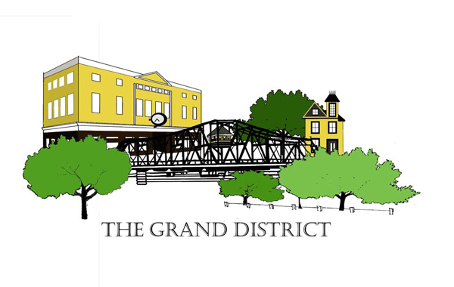

“Committed To Neighborhood Excellence”

V1. Issue 2
July- Sept 2017

Fair Haven
Management Team Meetings
Civic engagement is an honorable benefit for community residents. The power of community and neighborhood voices collectively echo together for the greater good of the people. Join the Fair Haven Management
Team at their monthly meeting held every first Thursday of the month at Columbus School – 255 Blatchley Avenue. Meeting starts at 6:00pm in the lunch room. Please note that July’s meeting is canceled. Meetings will resume in August.

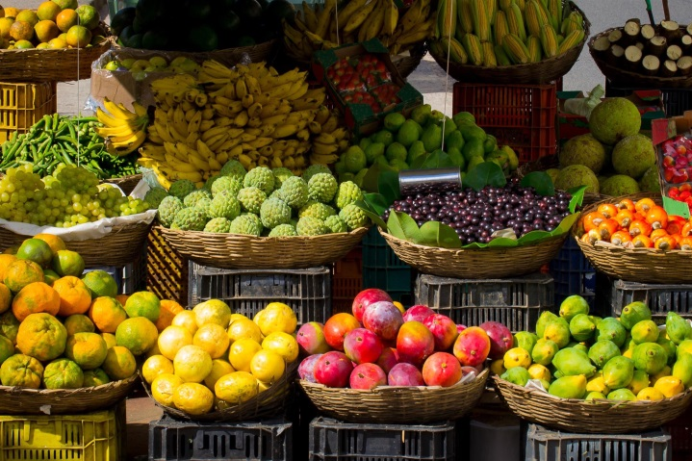
CitySeed
Farmer’s Market
The opportunity to purchase locally grown fruits and vegetables is an added benefit for the residents of Fair Haven. Nestled along the river, CitySeed plans to make its debut on July 6th! On Thursdays from 3-6 pm, join CitySeed on the Quinnipiac River Park on the corner of Front Street and Grand Avenue. Typically 4-6 vendors are expected to sell goods such as herbs, artisan breads, fresh fruits, vegetables and much more.
For more information about CitySeed, please visit www.cityseed.org.

Non- Profit Highlight
Grand Avenue is home to a variety of non-profit organizations who daily work for the benefits of the community. Check out some of the amazing work Arte, Inc.
Arte, Inc.
19 Grand Avenue.
Arte, Inc. is a non-profit organization whose mission is to, “… develop and promote Latino art, culture and education.” Through four power packed youth programs, Arte Inc. fulfills their mission on a daily bases. A.S.A.P. (After School Arts Programs) SLATE (Socialization & Learning Adventures Through Education) College Bound Road Trips and Family Arts and Science Workshop all provide the tools needed for participants to maximize their potential. For more information please visit www.arte-inc.com
“We need to preserve our small neighborhoods, our local businesses, our economy.”
-Maria Semple

Upcoming Events
This summer is packed with family-friendly events! Check it out.

June 23rd: Gospel Fest, New Haven Green
July 27th: Puerto Ricans United Inc. 2nd Annual Dinner Gala, Amarante’s Sea Cliff Rest
August 4-5th: CT Big 3 Ballout, 165 Church Street
August 5-6th: Family Fun Day, New Haven Green
August 12th: Second Annual Festival Puertorriqueno, New Haven Green

